| **Name:** | **James Lewis** |
| --- | --- |
| **Roll No:** | **32** |
| **Class/Sem:** | TE/V |
| **Experiment No.:** | 10 |
| **Title:** | Implementation of page rank algorithm |
| **Date of Performance:** |  |
| **Date of Submission:** |  |
| **Marks:** |  |
| **Sign of Faculty:** |  |

**Aim:** To implement Page Rank Algorithm

**Objective:** Develop a program to implement a page rank algorithm.

**Theory:**

 PageRank (PR) is an algorithm used by Google Search to rank web pages in their search engine results. PageRank works by counting the number and quality of links to a page to determine a rough estimate of how important the website is. Page Rank Algorithm is designed to increase the effectiveness of search engines and improve their efficiency. It is a way of measuring the importance of website pages. Page rank is used to prioritize the pages returned from a traditional search engine using keyword searching. Page rank is calculated based on the number of pages that point to it. The value of the page rank is the probability it will be between 0 and 1. A web page is a directed graph having two important components: nodes and connections. The pages are nodes and hyperlinks are the connections, the connection between two nodes. Page rank works by counting the number and quality of links to a page to determine a rough estimate of how important the website is. The underlying assumption is that more important websites are likely to receive more links from other websites. The page rank value of individual node in a graph depends on the page rank value of all the nodes which connect to it and those nodes are cyclically connected to the nodes whose ranking we want; we use converging iterative methods for assigning values to page rank. In short page rank is a vote, by all the other pages on the web, about how important a page is. A link to a page counts as a vote of support. If there is no link, there is no support.

We assume that page A has pages B.......N which point to it. Page rank of a page A is given as follows:

PR(A)=(1-β) +β ( (PR(B)/cout(B) )+ (PR(C )/cout(C ) )+-----+(PR(N)/cout(N) ) )

Parameter β is a teleportation factor which can be set between 0 and 1. Cout(A) is defined as

the number of links going out of page A.

**CODE:**

import java.util.*;

import java.io.*;

public class PageRank {

 public int path[][] = new int[10][10];

 public double pagerank[] = new double[10];

 public void calc(double totalNodes) {

 double InitialPageRank;

 double OutgoingLinks = 0;

  double DampingFactor = 0.85;

  double TempPageRank[] = new double[10];

  int ExternalNodeNumber;

  int InternalNodeNumber;

  int k = 1; // For Traversing

  int ITERATION_STEP = 1;

  InitialPageRank = 1 / totalNodes;

  System.out.printf(" Total Number of Nodes :" + totalNodes + "\t Initial PageRank  of All Nodes :" + InitialPageRank + "\n");

  // 0th ITERATION  _ OR _ INITIALIZATION PHASE //

  for (k = 1; k <= totalNodes; k++) {

   this.pagerank[k] = InitialPageRank;

  }

  System.out.printf("\n Initial PageRank Values , 0th Step \n");

  for (k = 1; k <= totalNodes; k++) {

   System.out.printf(" Page Rank of " + k + " is :\t" + this.pagerank[k] + "\n");

  }

  while (ITERATION_STEP <= 2) // Iterations

  {

   // Store the PageRank for All Nodes in Temporary Array

   for (k = 1; k <= totalNodes; k++) {

    TempPageRank[k] = this.pagerank[k];

    this.pagerank[k] = 0;

   }

   for (InternalNodeNumber = 1; InternalNodeNumber <= totalNodes; InternalNodeNumber++) {

    for (ExternalNodeNumber=1;

ExternalNodeNumber <= totalNodes;

ExternalNodeNumber++) {

     if (this.path[ExternalNodeNumber][InternalNodeNumber] == 1) {

      k = 1;

      OutgoingLinks = 0; // Count the Number of Outgoing Links for each ExternalNodeNumber

      while (k <= totalNodes) {

       if (this.path[ExternalNodeNumber][k] == 1) {

        OutgoingLinks = OutgoingLinks + 1; // Counter for Outgoing Links

       }

       k = k + 1;

      }

      // Calculate PageRank

      this.pagerank[InternalNodeNumber] += TempPageRank[ExternalNodeNumber] * (1 / OutgoingLinks);

     }

    }

   }

   System.out.printf("\n After " + ITERATION_STEP + "th Step \n");

   for (k = 1; k <= totalNodes; k++)

    System.out.printf(" Page Rank of " + k + " is :\t" + this.pagerank[k] + "\n");

   ITERATION_STEP = ITERATION_STEP + 1;

  }

  // Add the Damping Factor to PageRank

  for (k = 1; k <= totalNodes; k++) {

   this.pagerank[k] = (1 - DampingFactor) + DampingFactor * this.pagerank[k];

  }

  // Display PageRank

  System.out.printf("\n Final Page Rank : \n");

  for (k = 1; k <= totalNodes; k++) {

   System.out.printf(" Page Rank of " + k + " is :\t" + this.pagerank[k] + "\n");

  }

 }

 public static void main(String args[]) {

  int nodes, i, j, cost;

  Scanner in = new Scanner(System.in);

  System.out.println("Enter the Number of WebPages \n");

  nodes = in .nextInt();

  PageRank p = new PageRank();

  System.out.println("Enter the Adjacency Matrix with 1->PATH & 0->NO PATH Between two WebPages: \n");

  for (i = 1; i <= nodes; i++)

   for (j = 1; j <= nodes; j++) {

    p.path[i][j] = in .nextInt();

    if (j == i)

     p.path[i][j] = 0;

   }

  p.calc(nodes);

 }

}

**OUTPUT:**

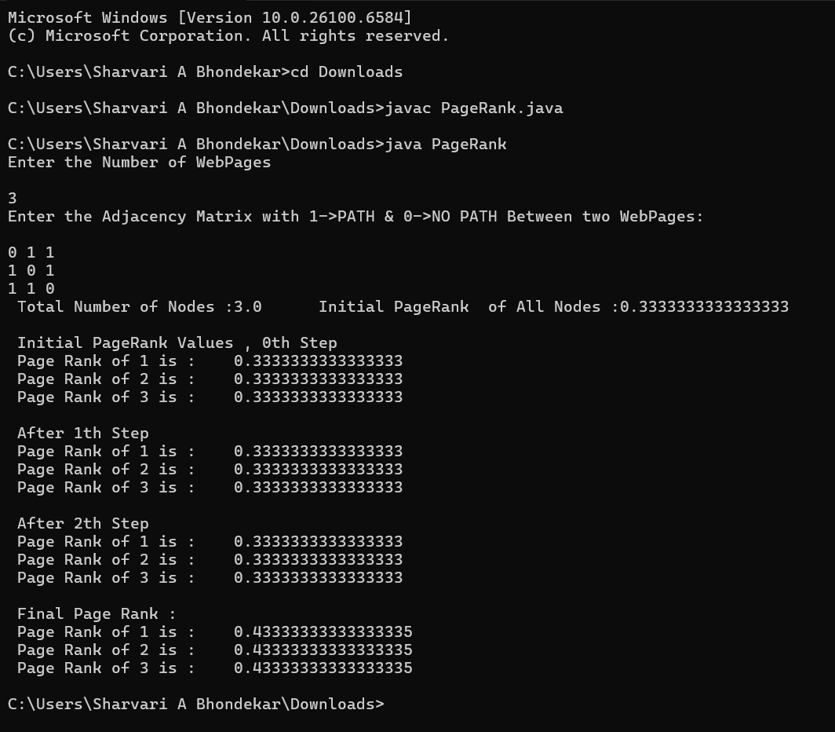

**Conclusion:**

**What are the key parameters of the PageRank algorithm, and how do they affect the algorithm's performance?**Key Parameters of PageRank and Their Effect on Performance

1. Damping Factor (β, usually 0.85)  
   * Represents the probability that a user continues following links instead of jumping randomly.
   * Higher β → importance of incoming links is emphasized, but convergence may be slower.
   * Lower β → ranks spread more evenly, faster convergence but less realistic ranking.
2. Number of Outgoing Links (Cout)  
   * A page’s PageRank is divided among all its outgoing links.
   * More outgoing links → less PageRank passed to each linked page.
   * Fewer outgoing links → more influence given to each target page.
3. Graph Structure (Adjacency Matrix / Link Distribution)  
   * Determines which pages point to which.
   * Pages with many incoming links from important nodes get higher PageRank.
   * Strongly connected graphs lead to smoother convergence.
4. Initial PageRank Values  
   * Typically set to 1/N where N is the number of pages.
   * Does not affect final values but influences how quickly the algorithm converges.
5. Number of Iterations / Convergence Threshold  
   * PageRank is iterative and values stabilize after multiple steps.
   * More iterations improve accuracy but increase computation time.